

Spirit Health

Diabetes Product Use Review Service

Service Introduction

April 2024

Service Overview
The Spirit Diabetes Product Use Review Service is a non-promotional medical service which is funded by Spirit Health and delivered by a team of nurses/technicians employed by Spirit Implement.
It is provided to practices where a need has been identified to review patients prescribed blood glucose testing strips and / or insulin pen needles to optimise their product use.

Service Objectives
The service is designed to assist GP practices across the UK with the delivery of improved care for patients using blood glucose test strips and/or insulin pen needles. The service aims to identify patients and optimise their product use in line with local formularies / guidelines.
This service aims to support practices by auditing current product use and make recommendations to optimise prescribing of blood glucose test strips and insulin pen needles for individual patients thereby reducing expenditure on the prescribing of blood glucose test strips and insulin pen needles.

About Spirit Health
Spirit Health launched in 2009 and is a multi-award-winning organisation that provides products and clinical services to the NHS and Local Authorities across the UK in an innovative and cost-effective manner. Spirit works with organisations to deliver medicines optimisation projects in accordance with local formularies and priorities.
Spirit has worked throughout the UK, implementing cost efficiency programmes to maximise savings for the local health economy whilst minimising the time and cost impact on practice & NHS medicines optimisation teams.
Importantly, Spirit has a reputation and proven track record of providing end-to-end solutions in the NHS and delivering against agreed outcomes. Published evidence suggests that an implementation with Spirit delivers 700% greater savings than making a formulary choice alone.

The Project Team:
- The Spirit Diabetes Product Use Review Service is delivered by a team of nurses, pharmacists & technicians employed by Spirit Implement, working on behalf of NHS Black Country ICB (Sandwell place)
- The Spirit coordination team and project manager will support the delivery of the service

Professional Standards:
The Spirit implementer team providing the service will have at least the following:
- Degree in nursing or MPHARM
- Registration with the Nursing & Midwifery Council (NMC) or General Pharmaceutical Council (GpHC)
- Minimum of 2 years post registration experience with experience of working in primary care
- Experience of working with GP clinical systems (Emis, SystmOne, Vision)
- Have undergone a DBS check

Review Service Process

Stage 1 – Service set up
- Spirit coordination team will discuss review service and requirements of both practice, and Spirit Health with the practice manager
- The practice completes and signs the Service Authorisation (via DocuSign)
(Spirit must be in possession of a completed Service Authorisation for the service to commence)

The service will be delivered on the understanding that person authorising the service will do so on the basis that the service provided is in the best interests of their patients. Practices always retain control of this service and their patients’ medical care.

- Spirit coordination team will request system access to practice manager. The practice will be required to register the SMART card for access to the practice clinical system and patient records

Stage 2 – Service Delivery
- Spirit implementer accesses the practice clinical system to carry out audit and notes reviews of patients using blood glucose test strips and / or insulin pen needles (remotely)
- Blood glucose meters will be ordered for delivery to the practice for patient collection
- The Spirit implementer will contact the nominated prescribing healthcare professional (HCP)) to authorise identified patients for a product change.

Insulin Pen Needles
Preferred Brand(s):……Insupen Original…………………………
- Spirit implementer will update patients’ electronic health record with HCP authorised recommendations
- Spirit implementer will communicate any changes to the patient

Blood Glucose Test Strips
Preferred Brand(s):……CareSens S-fit; CareSens Dual……………
- Spirit implementer will update patients’ electronic health record with HCP authorised recommendations
- Spirit implementer will communicate any changes to those patients with instructions to collect their new meter from the practice and useful resources to support its use.
- Patients will be offered optional virtual training sessions to demonstrate use of their new meter and answer any questions.
- If agreed with the ICB any additional diabetes education for patients will be provided at these sessions

Stage 3 – Service Completion
- Any identified training will be provided to the practice team as agreed with the ICB
- A service completion summary will be produced for the practice

Complaints Procedure:
Spirit Health are committed to providing any user of the service with the opportunity to raise concerns, seek advice or make a complaint. All Spirit personnel are required to report any complaints as per the Spirit complaints policy.

Safeguarding:
Spirit personnel will comply with local safeguarding policies and will ensure that all staff that are in a patient facing roles have the appropriate accreditation for the awareness of safeguarding responsibilities.

All Spirit personnel will adhere to the Spirit Safeguarding policies. This is mandatory and all staff must implement this policy and follow the procedures associated with it.

If a safeguarding concern is identified, the Spirit representative should report concerns to the practice safeguarding lead. The Spirit representative may wish to discuss and take advice from the Spirit safeguarding lead prior.

Equality and Diversity:
It is Spirit’s policy to provide equality to all patients, staff and other users irrespective of gender, including gender reassignment, marital or civil partnership status, having or not having dependents, religious belief or political opinion, race (including colour, nationality, ethnic or national origins), disability, sexual orientation, age, pregnancy and maternity, any other protected characteristic.

Appendix 1

Insulin Pen Needle Review Service
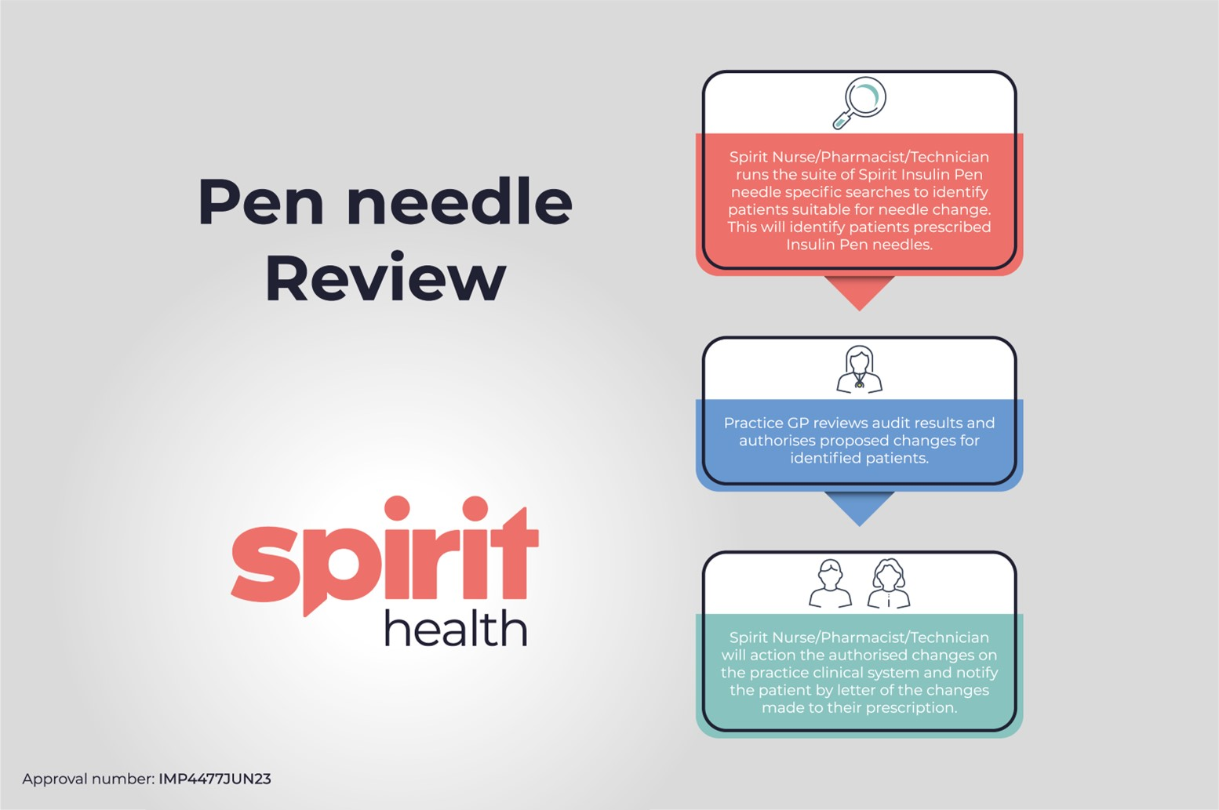

Appendix 2

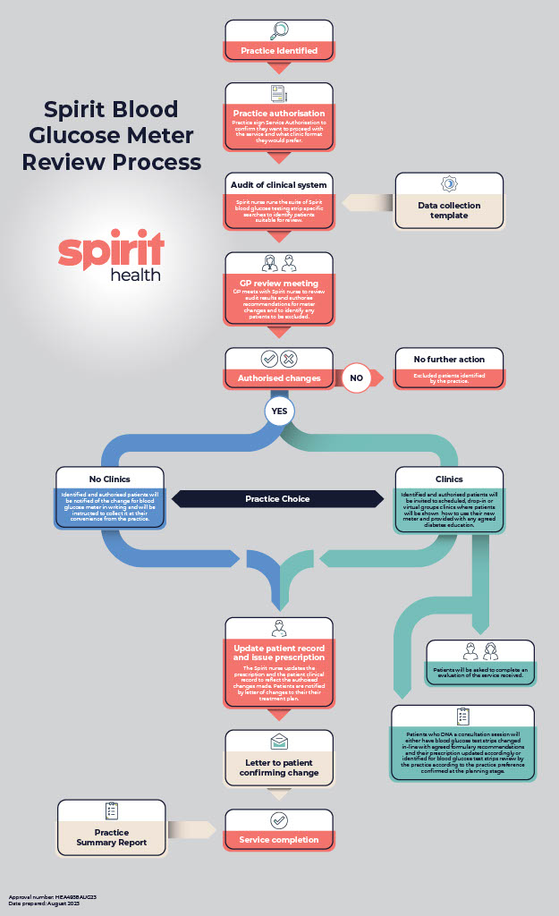
Blood Glucose Review Service

For further information about this service contact implementation@spirit-health.com

Spirit Health and Spirit Implement are trading names of Spirit Health Group Ltd
Swift J et al. Implementing formulary change in diabetes. British Journal Health Care Management 2016; 23 (4)

